**Airbnb**

**‘Shairbnb’**

Business Services Operations Research Event

Earl Haig Secondary School

North York, Toronto, ON M2N 3R7

100 Princess Avenue

Binder Nie, Elaine Wang, Ted Yoo

Jan.15.2020



**CONTENTS**

**I.** Executive Summary…………………………………………………………………………..…….. 1

**II.** Introduction……………………………………………………………………………………....…. 

**A.** Description of the Business or Organization…………………………………………….. 2

**B.** Description of the Community……………………………………………………………..

**C.** Overview of the Business or Organization’s Current Reputation and Online Brand Presence……………………………………………………………………………………….. 5

**III.** Research Methods Used in Study…………………………………...…………………….…....

**A.** Description and Rationale of Research Methodologies Selected to Conduct the Research……………………………………………………………………………………….. 6

**B.** Process used to Conduct the Selected Research Methods………...………………....

**IV.** Findings and Conclusions of the Study………………………………..………………………. 9

**A.** Findings of the Research Study…………………………………...………..……………. 9

**B.** Conclusions Based on Findings………………………………………………………….. 13

**V.** Proposed Strategic Plan…………………...…………………………………………………….. 14

**A.** Objective and Rationale of Proposed Plan……………………………………………… 14

**B.** Proposed Visions and Timelines…………………………………………………………. 14

**C.** Proposed Metrics of Key Performance Indicators to Measure Plan Effectiveness....



**VI**. Budget…………………..…………………………………………………………………………

**VII.** Bibliography…………………………………………………………….………………………... 19

# A close up of a device Description automatically generatedI. Executive Summary

The report will examine Airbnb’s current online brand presence and reputation as well as our team’s proposed improvement plans.

**Business Overview:** Airbnb is an online hospitality service that offers a platform for homeowners and travellers looking to monetize and find accommodations. Its innovative approach is reflected in its unique value proposition: an opportunity for guests to truly live like a local. With limitless housing options, from a single room to an entire mansion, Airbnb emphasizes inclusivity and belonging. Since the founding of this business venture in 2008, Airbnb has become a leading brand in the sharing economy, with over 6 million listings in over 190 countries around the world.

Figure 1: Host and customer relation

**Research methods used:**

|  |  |  |
| --- | --- | --- |
| **Primary Research Methods** | **Secondary Research Methods** | **Analysis** |
| * Google Form survey * Interview with Airbnb guest and host | * Various websites and databases | * SWOT Analysis * Competitor’s Analysis |

**Proposed campaign idea:**

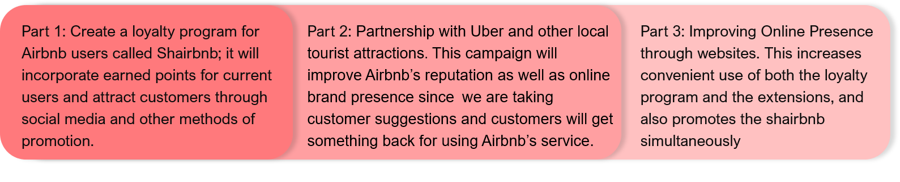

*Figure 2: Loyalty Program Summary*

|  |  |
| --- | --- |
| **Problems within Business from Research** | **Shairbnb Solutions** |
| 1. Non-existent rewards program, leading to lower customer retention and online presence 2. Guests find travelling to new locations inconvenient as they are not familiar with the means of transportation 3. Criticism against Airbnb’s social responsibility and negative affect on neighbourhoods. | 1. Loyalty Program:  * customers feel appreciated by receiving rewards * creates a long-term relationship between the brand and guests  1. Partnering with Uber and local attractions:  * Help customers travel more conveniently * Benefits the community through money gained from tourists. |

**Proposed Budget:** $ 3,298,899 CAD / year in Toronto only

Figure 3: Timeline of Proposed plan



# II. Introduction

# The Bélo: Airbnb's symbol of belonging A. Description of the business or organization

Airbnb is an online marketplace that connects people who wish to offer their living quarters with customers looking for accommodations in the locale. The company’s modern hospitality concepts are reflected in how it was created and the services that it offers. The business venture was co-founded in August 2008 by Brian Chesky, Joe Gebbia, and Nathan Blecharczyk in San Francisco, California. They created the company in retaliation against the unaffordable housing market in San Francisco.

Figure 5: Timeline of Airbnb’s key developmental milestones

Figure 4: Bélo: Airbnb’s logo



**2008**

Air Bed and Breakfast is incorporated: co-founded by Brian Chesky, Joe Gebbia, & Nathan Blecharczyk

The company changes its name to **Airbnb** and expands into offering vacation homes

**2009**

Achieves net worth of

$40 billion

**2016**

**2014**

Rebrands and introduces the Belo, a symbol of belonging

Airbnb officially receives 2 million+ guests each night in 190+ countries

**2019**



**2009**

They receive first funding from the seed accelerator, Y Combinator

**2010**

Launch of mobile app

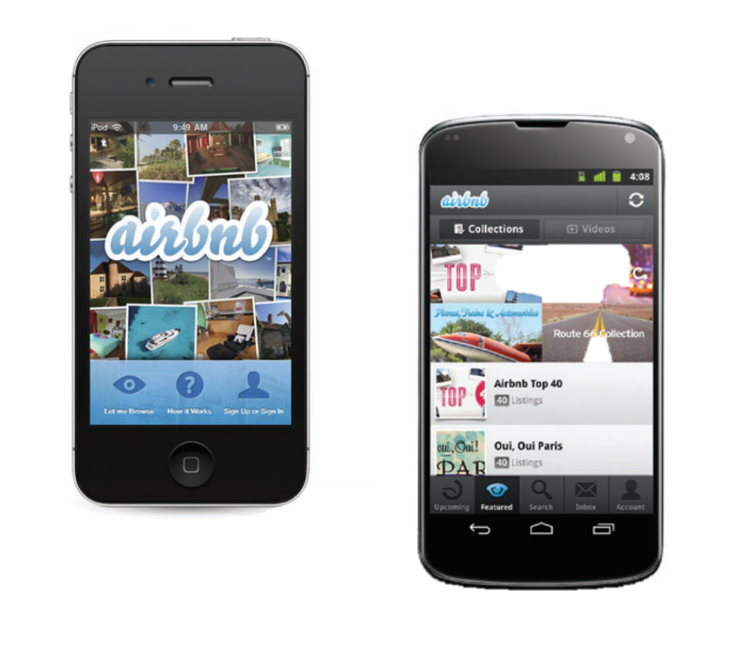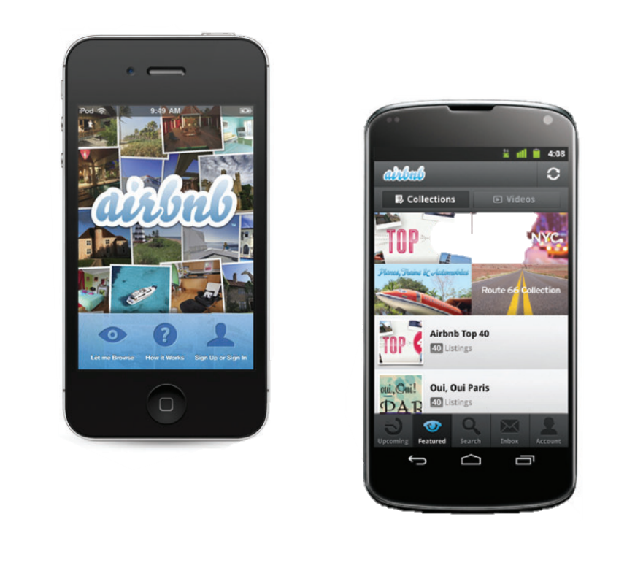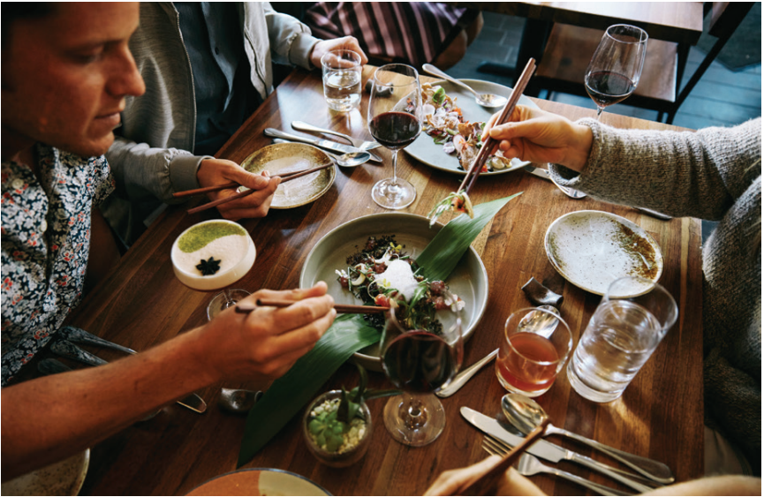

Airbnb and Ressy team up to offer in-app restaurant reservations

**2017**

Begins international expansion

**2011**

Airbnb’s Target Market

Today, Airbnb is an international service that allows people to efficiently list, discover, and book accommodations in more than 190 countries—online or from a mobile app. It is known for its unprecedented customization that allows guests to book locations based on elements that they value to most, whether that be safety or comfort. This is achieved through its unique hospitality services that differ from those provided in the traditional hotel industry.

|  |  |
| --- | --- |
| **Demographics** | **Psychographics** |
| * For all ages and income levels * Homeowners, renters, and travellers | * Economical individuals * Adventurous tourists |

**Hospitality Services:** Property owners are able to list their homes for free on the Airbnb website and are charged 3% for each booking or 20% of each experience they host. As a guest, one would be charged from 5-15% of their subtotal. Travellers and hosts are invited to submit online reviews of the vacation rentals and guest behaviour, respectively. As a result, both parties are encouraged to uphold high standards of conduct. Other services that guests are privy to include the ability to maintain direct communication with the host through a messaging system, price and cancellation flexibility, and the choice over a wide selection of lodgings—single rooms, apartments, villas, and houses are all available.

**Tourism-related activities:** Airbnb strives “to help create a world where you can belong anywhere, where people can live in a place, instead of just travelling to it.” In hopes of enhancing the community, the company provides the following services: Experiences (activities guided by locals), Airbnb Adventures (Multi-day trips led by Airbnb hosts), and Airbnb Collections (homes specialized for specific purposes: work, honeymoons, etc.)

**Location:** A central area of Airbnb locations in Toronto is the Spadina Fort York region. West of central downtown, this is a popular place for customers of all demographics to visit, making our research more convenient. Additionally, the location serves as a popular district for sports and entertainment businesses, which increases the factor of tourism in our study.

# B. Description of the community

**Geographic:**

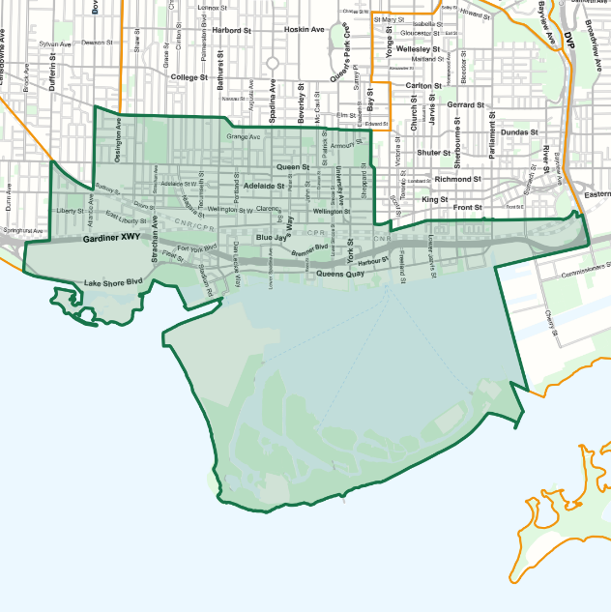 The downtown core or central business area in Toronto is located within the northern part of the Greater Toronto Area (GTA). Within this region, the highest concentration of Airbnb hostings can be found in ward 10 of the city, Spadina-Fort York. The influx of tourists and Airbnb guests can be attributed to the numerous tourist attractions and cultural facilities located there: museums, monuments, Queen’s Park, Harbourfront, and many more points of interest.

As the central-most district of Toronto, any location in the Spadina-Fort York region can be easily accessed with a drive or local and regional public transportation services.

Figure 6: Map of Spadina-Fort York region

Map of Spadina-Fort York region; Ward 10

Transportation Access within the Spadina-Fort York Region

|  |  |  |  |
| --- | --- | --- | --- |
|  | Transportation Method | Destination | Estimated Time |
| Local | Toronto Transit Commissions | Union Station | 5 – 20 minutes |
| Regional | GO Train | Union Station | 5 – 25 minutes |
| Global | Airline Transportations | Pearson Airport | 40 – 70 mitnutes |

**Demographic:**

Today, the population of the Spadina-Fort York region exceeds 115 000—more than 40% of the downtown population of Toronto. The 2016 Canadian census shows a 40.1% population growth, exponentially larger than the overall 4.5% population growth of Toronto. In accordance to the high population growth, more than 30% of the population are immigrants, creating a multicultural environment with a variety of ethnic groups: English (9.4%), Chinese (9.1%), Irish (8.3%), Canadian (8.0%), and the Scottish (7.5%). The variety of ethnic groups in the region portrays the diversity of the community and provides opportunities to research subjects that hold different perspectives.

Figure 7: Ethnic Percentages

Additionally, a large percentage of the population are mobile (32%), leading to a large community of prospective Airbnb customers.

**Economic:**

Broad economic indicators point to stable growth momentum in Ward 10’s economy. Gains in the region's economy were driven by service sector expansion with substantial benefits in wholesale and retail trade (4.3%), transportation and warehousing (12%), and professional/technical services (5%), and health and social services (5.5%). In addition to specialized services, the tourism industry continues to serve as a backbone to the economy of the Spadina-Fort York region. The diverse commercial infrastructure and multiple tourist attractions garner millions of tourists; each year, the Toronto Eaton Centre attracts over 47 million tourists alone. Rising employment and income trends outcompete Toronto’s growth; the average income of those in the Spadina-Fort York region surpasses $66 000, whereas the average salary of Toronto is $52 000. In addition, retail sales in the Spadina-Fort York outpaced provincial and national growth, reflecting strong consumer demand, rising population growth, and increasing tourism. Economic prospects in the region are expected to lead provincial growth, given its role as a global financial hub, headquarter base for various industries, diverse economic support, and attraction for new immigrants.



**Socioeconomic:**

Rising employment and income trends outcompete Toronto’s growth; the average income of those in the Spadina-Fort York region surpasses $103 000 whereas the average salary of Toronto is $98 000. In addition, retail sales in the Spadina-Fort York region have outpaced provincial and national growth, reflecting strong consumer demand, rising population growth, and increasing tourism. In relation to the high average income of this area, residents have a higher spending average than that of Toronto, with upwards of 45% of tenants spending more than 30% of their yearly income on shelter costs. Finally, 95% of the population have at least obtained a high school diploma, indicating the top social-economic position of this neighbourhood.

Figure 8: Highest Education for high school diploma of those >15 years

# C. Overview of the business or organization’s current reputation and online brand presence.

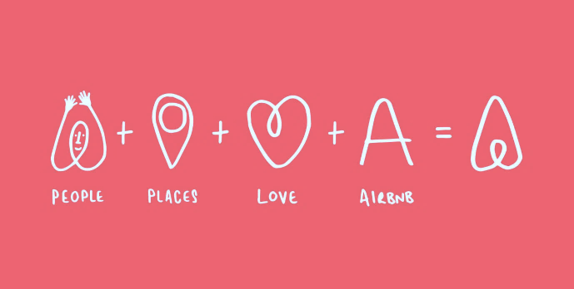

Since the launch of Airbnb in 2008, the company has continued to aspire towards “creating a world where anyone can Belong Anywhere” through their multifaceted services. It has created a name for itself in the travel industry as a poster child for a movement bigger than itself—unbiased hospitality and a strong sense of community. Accordingly, the company constantly revises and rebrands itself to effectively communicate this idea through the brand. Their current logo, theBélo, encompasses values of belonging and is imbued with four meanings: people, places, love, and Airbnb.

Figure 9: The symbols and ideas that formulate Bélo.

:

**Partnerships:** The United Nations Children's Fund (UNICEF), Year Up, The Arc, International Olympics Committee (IOC), and other organizations work together with Airbnb to support access to shelter for everyone, including the low-income and underprivileged. They communicate the importance of accessibility and inclusivity in the platform.

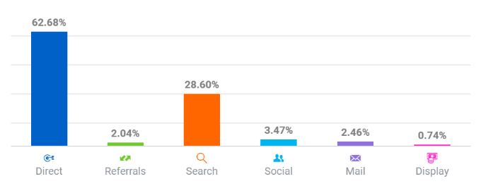**Campaigns:** “That’s why we Airbnb” is one of the many campaigns that reinforce the idea of global community. Travellers worldwide would share stories of their experiences on the Airbnb site, publicising its unique selling proposition: a community-driven platform. This campaign supports individuality, essentially appealing to each person’s unique needs rather than expecting conformity to the conventional offerings and experiences available to tourists.

Figure 10: Traffic Sources for Airbnb.

Figure 9: The symbols and ideas that formulate Bélo.

**Social Media:** Airbnb is also active on various social media networks in order to grow their online brand presence and increase redirection to its website: Twitter, Facebook, LinkedIn, YouTube, and Instagram. Figure 10 shows the strong influence social media marketing has on the company’s online traffic. The company uploads unique content to each media outlet, appealing to the distinctive target market of the users of each social media platform. For example, Airbnb’s Instagram content is predominately user-generated content; this emphasizes the authentic, tourist-friendly, community-driven aspect of Airbnb. On the other hand, it uses Twitter to maintain positive and friendly interactions with it’s customers by responding quickly to 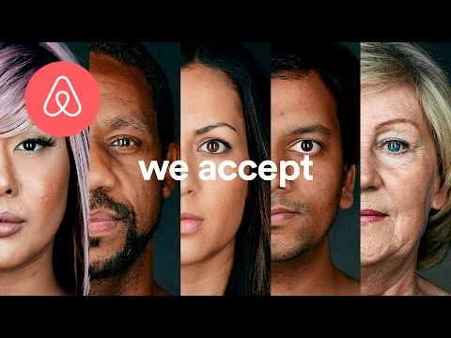complaints and unhappy clients. Finally, Airbnb uses YouTube ads to reach a large audience and expand its target market. For example, their 2018 ad, “we accept”, reached 5 million views and was used to introduce and advertise their non-discrimination policy and underpin Airbnb’s long-held values of acceptance and culturally diverse travel.

**Controversies and criticisms:** Some of the most common unresolved complaints neighbours of Airbnb locations have against guests include invasion of private property and the noise level at night. This damages Airbnb’s reputation and leads to criticisms against its indulgent policy towards bad guests. In addition, many criticize Airbnb for encouraging guests to repurpose units that might otherwise be used for long-term housing. This puts a strain on the housing market, increasing rent and housing prices.

Figure 11: Airbnb past “we accept” campaign

# III. Research Methods Used in Study

# A. Description and rationale of research methodologies selected to conduct the research study.

**Rationale of research**

The purpose of this research is to gain knowledge about the experiences of customers and hosts on Airbnb. Through our research in November and December 2019, our group gained insight on the opinions held by multiple stakeholders, allowing us to comprehend the current online market and determine opportunities for growth. Our ultimate proposition addresses every aspect of the global brand identity with the purpose of growing Airbnb’s online presence and reputation among its users.

|  |  |  |
| --- | --- | --- |
|  | **Types of Studies Conducted** | **Analysis** |
| * 1. **Primary**   2. **Research** | * Google Forms survey   (186 responses)   * Interviews   (With Airbnb host and use) | * SWOT analysis * Competition analysis |
| **Secondary Research** | **Websites** | **Databases** |
| * airbnb.ca * news.airbnb.com * toronto.ca * vrbo.com * secondmeasure.com | * 2016 Canadian Census * City of Toronto |

***Online Survey*** (186 responses)

Description: This Google Form survey was uploaded on November 17th and was shared through various social media platforms—Facebook and Instagram. Moreover, this survey circulated through the students and teachers of Earl Haig Secondary School. This survey was disclosed on December 23rd.

Rationale of survey: Through this survey, we learned about Airbnb’s reputation and presence amongst users and the general public. Through the diverse participant group, we can incorporate the attitudes of the complete target market of Airbnb—everyone. We investigated the quality of customer and hosting experiences at Airbnb locations, criticisms towards the company, and expectations for future improvements.

***Interviews***

Description: Our team interviewed two people: Shawn, an Airbnb host in downtown Toronto, and a regular customer of Airbnb services. The interview with Airbnb host Shawn was conducted on December 23rd, 2019, and the interview with the guest of Airbnb was conducted on December 28th, 2019.

Rationale of interview: To understand the perspectives of hosts and guests on Airbnb surrounding the feasibility and demand of our proposed plan. Interviews are an essential part of our research since they are a primary source of information and understand of the demand for our proposed plan. The answers to specific questions give insight into what customers like and dislike about the service.

***SWOT Analysis***

Description: Conducted analysis on December 23rd, after 186 survey responses, 2 interviews as well as a competitor’s analysis.

Rationale of SWOT analysis: Closely examine Airbnb’s strengths, weaknesses, opportunities and threat to their company. Obtain more knowledge on Airbnb’s overall position amongst competitors in this market



***Competitors Analysis***

Description: Our team stayed at an Airbnb hosting, as well as a location of an Airbnb competitor, VRBO; both had similar price points and ratings on their respective sites. During our stay, we recorded every aspect of the services provided.

Figure 12: VRBO; Airbnb Competitor

Rationale of Competitors analysis: By conducting an in-depth immersion into both Airbnb and competitor locations, our team can more clearly understand the pros and cons of each service.

# 

# B. Process used to conduct the selected research methods

Online Survey Questions

|  |  |  |
| --- | --- | --- |
| **Multiple Choice** | **Scaled Response** | **Short Answer** |
| * What is your age group? * How often do you travel? * Where do you usually travel to? * How many times have you used Airbnb services? * Would you recommend Airbnb to your friends? * Would you choose Airbnb over a hotel? * How were you introduced to Airbnb? | * Rate your stay at the Airbnb location from a scale of 1- 10. * How safe do you feel at an Airbnb location from a scale of 1-10? | * What services have you heard of from Airbnb? * How would you describe Airbnb? * How would you improve Airbnb? * How should home sharing be improved? * What other services should Airbnb bring to the table? |

***SWOT Analysis***

Our team visited and stayed at an Airbnb and VRBO location for one night. over the months of November and December. During the 2 visits, we talked to both of the hosts of the location we stayed at. On top of staying at an Airbnb and a competitor or its location, we also researched on their companies through online resources. Their website gave us information on their strengths, weaknesses, threats and opportunities compared to each other, and we were able to carry on our SWOT analysis from there.

Moreover, we were able to find out more about each company’s operating strategy with interviews, the similarities and the differences in the ways that they operate and their business strategies. A completed SWOT analysis is presented below in a table format on page 12.

|  |  |  |  |  |  |
| --- | --- | --- | --- | --- | --- |
| **Interviews**  Questions Directed at Airbnb Host Shawn | | | | | |
| **Personal Questions** | | **Questions Surrounding Guests** | | | **Analysis Questions** |
| * What are you most passionate about working being a host in Airbnb? * How long have you been an Airbnb host? * Have you encountered any issues with security in your time being a host? * Do you plan on continuing to be an Airbnb host? * Do you have security cameras and other security measures in your Airbnb location? * How did you hear about Airbnb and how did you become a host? | * How do you screen your guests and make sure they will not damage your property? * On average, how many customers do you get every year? * On average how long do guests stay at your Airbnb location? * How do guests contact you? (e.g. through app, or website) | | | * Do you think your location is a good place to host at? * Do you think security plays a big factor in being a host? * Have you heard of Airbnb competitors such as Flipkey and VRBO? * Do you stay in the same house while Airbnb guests occupy the location? * Do you think Airbnb services have improved over the years? * How would you improve Airbnb services? |
| *Questions directed to Airbnb User* | | | | | | |
| **Personal Questions** | | | **Airbnb Questions** | | | |
| * How often do you travel? * When you travel, do you usually look to Airbnb or would you turn to a hotel first? * What do you usually use Airbnb services for? * How long have you been a customer at Airbnb? * Would you choose to stay at an Airbnb location or a hotel? Why? * Have you used a service from a competitor of Airbnb’s? Such as VRBO or Flipkey? | | | * How often do you use Airbnb services? * How would you rate most of your stays at Airbnb locations? * What services have you used at Airbnb? * Do you feel safe at an Airbnb location? * Have you used Airbnb services internationally? If you have, what were some of the differences? * How would you improve Airbnb? | | | |

***Competitors Analysis***

In the Airbnb and VRBO locations, our team documented the features of each service: the cleanliness, location in the city and proximity to key locations, the quality in comparison to the pricing, safety, authentic service, and available provisions (water, toiletries). Moreover, we analyzed the competitor’s profitability, growth pattern, marketing objectives, current and past marketing strategies, organizational and cost structure, target market, and the strengths and weaknesses of the company through online databases. As well, our team analyzed each company’s website and app services as those platforms are where most of the service bookings are made.

# IV. Findings and Conclusions of the Study

# A. Findings of the research study

**Findings from survey:**

**Most desirable amenities: safety** (24%) and convenience (38%) throughout their stay.

Guests want to be able to easily travel to stores, restaurants, local attractions, or wherever they please from the residence. Although many Airbnb homes are located near the centre of the city, some are inconveniently situated at the edge of the Spadina-Fort York region, requiring transportation from the Airbnb location to the core of the commercial centre.

Figure 13: Airbnb Desirable Features

Many past guests have reported problems regarding the reliability of the app; deceitful and misleading property pictures and descriptions occur frequently, damaging the trustworthiness and the safety of the company, which is the second most desirable aspect of a hospitality service.

 **Airbnb Rating:** On a scale of 1 to 10, only 12 of 137 people rated their stay with Airbnb at a score of 5 or lower. Their reasons for disliking the experience involved the cleanliness of home and inconvenient location. 66% of the people surveyed rated 8 or higher–they believed the Airbnb experience was more authentic and comfortable compared to other accommodations.

Figure 14: Rating of Airbnb Services

**Marketing:** 96% of people are willing to recommend Airbnb to their friends and encourage them to try stay at an Airbnb location over a hotel. This indicates an effective word of mouth advertising strategy amongst Airbnb users. However, only 22% of the Airbnb users have heard of Airbnb from an advertisement or a promotion from Airbnb itself, such as through social media platforms and advertisements online. From this, our team has learned that Airbnb needs to improve its advertising and promoting of the company.

Figure 15: Awareness of Airbnb Services

**Reputation:** Based on the amount of people aware of Airbnb’s social initiatives (26%), it is evident that people have a positive perception of the company. However, many people are unfamiliar with services that directly improve customer experiences such as airport drop-off/pickup (1%) and Airbnb Adventures (2%).

**Industry Compeition:** 53% of the 186 people surveyed travel once a year, 20% of the participants travel more than twice a year, 15% travel more than 3 times a year, and 5% travel more than 5 times a year. Since all the survey participants that travel every year visit countries that contain Airbnb locations, there is a large number of potential future customers. Although 93% of the respondents travel each year, 137 people of the 186 have stayed at Airbnb locations—therefore, 20% of the total survey population chooses hotels and competitor locations over Airbnb.

34% of the participants have heard of other competitors like Flipkey and VRBO. Out of these 63 people, 30 have stayed at a competitor’s location and used their services. From this, we learn that Airbnb is the dominant company in its market.

**Findings from interviews:**

Interview with Airbnb host:

On December 23rd, 2019, we interviewed Airbnb Superhost, Shawn. He joined the platform in 2017 and became a Superhost in 2018. A Superhost is a host with consistent exemplary reviews, a rating of 4.8 stars, and over 100 guests per year. Through the interview, we gained the following information:

* 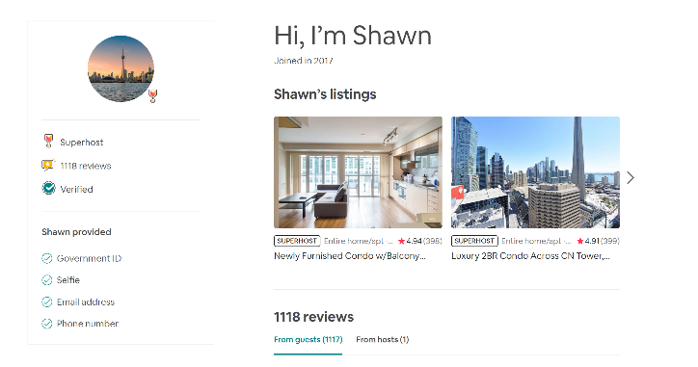Airbnb is seen as one of the easiest ways to monetize property. Shawn reported earning around $2 000 per month with his three locations in downtown Toronto.
* 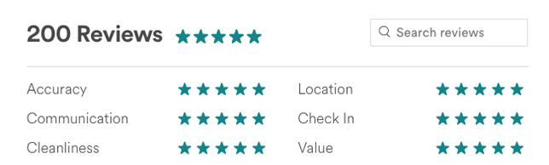The profitability of each Airbnb largely depends on the location; those near main attractions or with convenient access to transportation are likely to have more guests.

Figure 17: The host’s listing on Airbnb’s website

Figure 16: Photo of Binder Nie and Ted Yoo with Airbnb host. Not pictured: Elaine Wang

Interview with guest:

On December 28th, 2019, we conducted a phone interview with an Airbnb guest, who has been using the services since 2015. They have also used other online hospitality platforms like VRBO and Flipkey:

* Many customers are unaware or uninterested in services such as car rentals, restaurant reservations, and tour guide services. However, they help enhance the customer experience, emphasizing the company’s vision to create a community-driven service.
* Guests assess listings mainly based on reviews made by other guests. The site depends of active reviewers to give property details as the listing description made by the host may not be accurate.
* On VRBO, one can only rent entire homes, ensuring complete privacy. However, the guest prefers Airbnb over VRBO due to security, convenience, and unique experiences only found on Airbnb. The guest believes that one of its strengths is the extensive network of hosts and locations that offer an infinite number of options.

**Findings from SWOT:**

SWOT Analysis

|  |  |
| --- | --- |
| **Strengths** | **Weaknesses** |
| * 24/7 reliable and fast customer service * Owns largest market share (19%) against industry competitors such as VRBO. * High and growing retention rate (40%) * 191+ countries around the globe * Airbnb offers multiple services, touching into various markets * Service differentiation: locations are customized by the hosts and customers are provided with authentic experiences | * Controversies about the affects of Airbnb on the housing market affects brand reputation * Unclear and complicated booking process: many service fees enforced by the host and rules * Inconsistency between listing photos and reality affects credibility * High operational costs for hosts |
| **Opportunities** | **Threats** |
| * Partnerships with other companies, especially those affiliated with tourism * Improve convenience for guests * Development of a website and app that is easier to navigate * Creation of a loyalty program | * Similar competitors such as VRBO and Flipkey * Unpleasant experiences due to host or customer behaviour in which Airbnb has no control over |

**Findings from Competitors Analysis:**

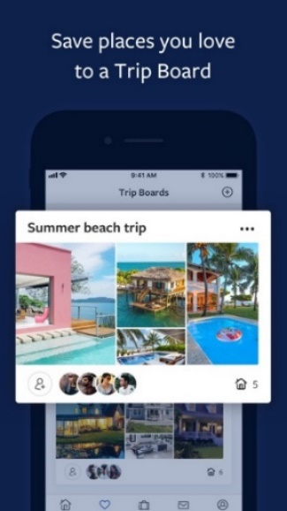 VRBO Analysis

Figure 18: VRBO’s feature: Trip Board

|  |  |
| --- | --- |
| **Strengths** | **Weaknesses** |
| * Very clear booking process * Extensive keyword searches allow guests to find exactly what they are looking for * Unique feature: the “Trip Board” allows users to favourite and comment on different locations. together with other VRBO guests. This allows them to plan out their trip through the app. | * Small selection of rentals (3 million) * Homeowners must pay complicated service fees * More expensive * Small online presence |

Advantages of Airbnb over VRBO: Airbnb is more inclusive of all demographics; it is not just a platform for tourists to find a place to stay for the duration of their trip, the site also offers services such as a guided tours and airport pickups/drop-offs that are unique from other competitors. Airbnb also has a cost competitive advantage: it offers a wider variety of accommodations for a lower price than VRBO, who only offers full properties. Finally, Airbnb effectively increases its online presence by using user-generated content, staying active on social media, and releasing new campaigns and updates.

# B. Conclusions based on findings

In order for Airbnb to improve its online reputation and brand name, the company should provide services that enhances comfort and convenience for guests as well as update its online services— it’s website and app.

**Conclusions made:**

1. Based on the findings from the survey, we found that the reputation and credibility of Airbnb is compromised by the complicated booking process. The multiple fees do not reflect the affordable image originally insinuated by the company. The interview with the guest has also shown that the platform is not reliable as many listings are perceived to be deceiving. Although many people are aware of the Airbnb’s social efforts like their anti-discrimination campaigns, these criticisms prove that the reliability of its service and therefore reputation of Airbnb can be improved upon.
2. Airbnb holds the largest market share against industry competitors: this can be seen from the survey results where very few participants knew about competitors such as VRBO or Flipkey. However, Airbnb should improve its advertising and promoting strategies since only 22% of people heard of Airbnb from their advertisements and the rest from their family or relatives. By improving our advertising, Airbnb has the potential to reach many potential costumers.
3. Through our interview with the Airbnb guest, we concluded that value-added services play a large role in determining the online presence of a company; unique Airbnb experiences like guided-tours influence customer loyalty and increase cloud marketing—the use of social media to increase publicity and online presence. From the competitor’s analysis, we learned that VRBO also offers a valuable service that attracts guests, the “Trip Board”. This reveals that Airbnb should create a service or a program that can create more enjoyable experiences. From the results of our survey, 38% of people believe that convenience is a key aspect of hospitality, indicating that Airbnb should implement a plan that would enhance this feature for guests.

# V. Proposed Strategic Plan

# A. Objective and Rationale of the proposed plan

**Objectives:**

* Increase customer loyalty
* Accommodate tourists and aid the local community by providing bonuses and incentives when purchasing in selected tourist locations
* Increase service differentiation and improve reputation of the company by adding a more convenient transportation service

**Rationale:**

Our proposed strategic plan will improve Airbnb’s online presence through our new loyalty program; the points system and special benefits will increase the number of returning customers and long-term loyalty. This will also encourage customers to try out Airbnb’s other tourism-related services that offer rewards, in turn, created more user-generated marketing.

Reputation will be improved through better quality control that will be achieved through partnerships. We discovered that the level of customer satisfaction is highly dependent on the host’s location and relation to tourist attraction. By cooperating with the ride-hailing company, Uber, Airbnb guests will be able to travel in greater comfort.

**B. Proposed Visions and Timelines**

*****Overview of vision: “Inairvate”*

Step 1: Loyalty Program

Step 2: Partner Extension, Additional Benefits

Step 3: Promotion and Online presence marketing

*Step 1:* Introduce Loyalty Program: “Shairbnb”

*Rationale:*

The Airbnb loyalty program is a system that not only rewards tourists for staying with Airbnb but is also targeted towards a diverse group of people travelling for different purposes. By receiving rewards from the company, people will associate positive feelings with the platform. Our vision is to create a stronger connection between the brand and its customers by demonstrating their importance and belonging in the community.

Figure 19: Poster for our proposed plan with slogan, “Inairvate”

*Overview:*

Shairbnb: “Shairbnb” is the selected name of our structured rewards system. Users will automatically be sorted into 4 different tiers based on the amount of nights they have stayed with Airbnb: Member, Tourist, Premium, or Elite. They will be notified of this rewards program through an email newsletter.

Status and Point Requirements

|  |  |  |  |
| --- | --- | --- | --- |
| **Tier** | **Nights of Stay Required** | **Points Earned per Night** | **Points Required for 1 Free Night of Stay** |
| Member | 0 | 2 | Not Available |
| Tourist (Shairbnb) | 5 | 4 | Not Available |
| Premium (Shairbnb) | 15 | 6 | 120 |
| Elite (Shairbnb) | 30 | 8 | 100 |

The value of each point is $0.75 CAD (points will not be convertible to cash and vice vera)

**Ways to Earn Points:**

1. By staying at any Airbnb location around the globe, each guest will receive points in accordance to their tier status (on table shown above).
2. By visiting tourist attractions across the globe.

**Redeeming points:** Points will be redeemable for a free booking only in Toronto.

If the 1-year trial of this campaign is well-received, we will implement this plan at a global scale, making it possible for users to redeem and gain points through Uber internationally.

*Step 2:* Partnership with Uber and Local Attractions

*Rationale:*

 Uber is an online ride-hailing company that strives to use its services to improve the efficiency and safety of its guests’ lives. They provide a wide array of vehicles that enables a seamless travel experience for all its customers, whether that be a family, company, or single rider. By partnering with Uber, the importance of customer convenience and comfort will be successfully conveyed through the brand.

Figure 20: Airbnb & Uber Logos

We will also establish partnerships with local tourist attractions. Airbnb and attractions like museums and monuments will both increase their relevance and its addressable market by benefitting from each other’s popularity. This partnership will address Airbnb’s social responsibility to the community; by encouraging tourists to spend money in the city, the community is ultimately generating revenue.

*Overview:*

Currently, Airbnb offers locally guided tours that would allow tourists and customers to explore the city. However, surveys indicate that 38% of customers want Airbnb to become convenient and offer services that will benefit them. Our plan provides each tourist with a designated driver from Uber, allowing them to easily navigate through an unknown area comfortably. This eliminates the confusion customers face with an unfamiliar public transit system or wait time spent hailing a taxi.

Uber Costs and Points

|  |  |  |  |
| --- | --- | --- | --- |
| **Tiers** | **Flat Rate per Day**  **(CAD)** | **Rate per Kilometer**  **or part thereof (CAD)** | **Points Earned per Use**  **(Shairbnb)** |
| Member | $25.00 | $2.00 | 2 |
| Tourist | $23.99 | $1.89 | 3 |
| Premium | $21.99 | $1.69 | 4 |
| Elite | $20.00 | $1.49 | 5 |

Local Tourist Attractions: When guests purchase admissions to certain attractions in the country they visit, they will receive Shairbnb reward points. These points of interest include museums, amusement parks, famous restaurants, as well as seasonal and special events.

Local Attraction Rewards

|  |  |
| --- | --- |
| **Number of Attractions Visited** | **Points Earned** |
| 4 or less | 1 point for each attraction |
| 5 | 8 |
| 6 | 10 |
| 7 or more | 13 |

*Step 3: Website and App Development*

*Rationale:*

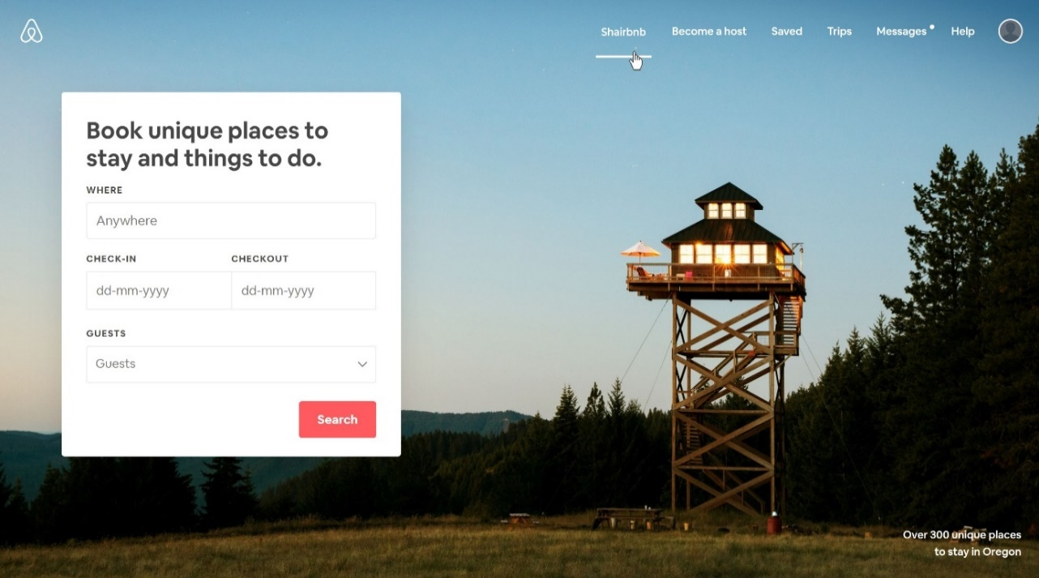Developing a visually attractive website will make it more convenient and pleasing for guests to use. A straightforward and easily comprehendable website will help guests learn, use, and redeem faster through our Shairbnb campaign. Shairbnb will be added to the navigation menu of the homepage in order to quickly guide customers to the campaign page.

Figure 21: Shairbnb website demo

*Overview:* 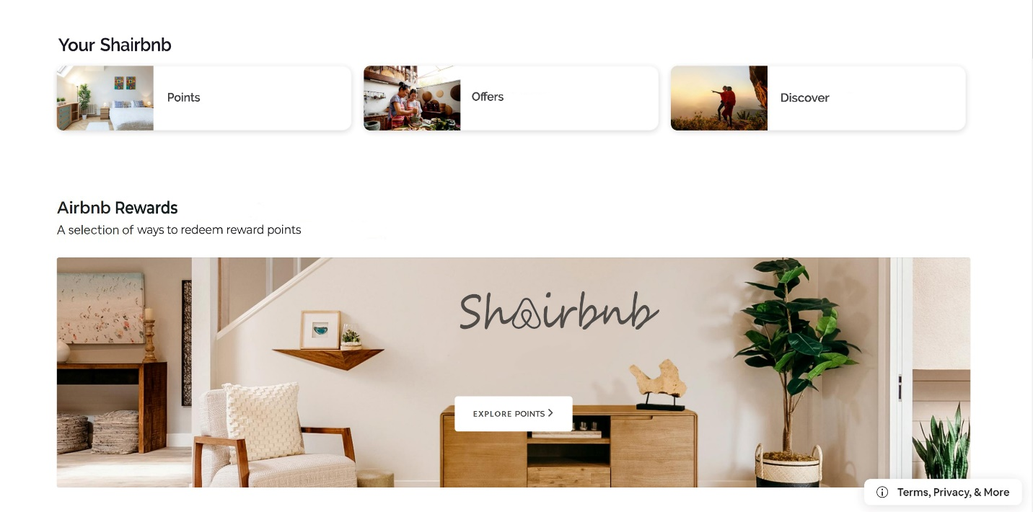To facilitate a more convenient experience, we will create pages and sections dedicated to the campaign on the Airbnb website. The information that will be available on the member’s status includes the number of nights stayed, current shairbnb tier, current points, available redemptions and many more.

Figure 22: Shairbnb page demo

*Timeline:* We will only be implementing this campaign in Toronto from June 2020 to June of 2021. After one year, we will analyze the performance of the campaign with key metrics. If the campaign is successful, we will be implementing this campaign internationally.

Figure 23: Shairbnb campaign timeline

# C. Proposed metrics or key performance indicators to measure plan effectiveness

|  |  |  |  |  |
| --- | --- | --- | --- | --- |
| * + - 1. **Standards of the Points system** | | | | |
| **Performance** | **% of people using Shairbnb** | | **Increased percentage (%) of average nights spent at Airbnb/year** | |
| Excellent | 90 ~ 100% | | > 50% | |
| Good | 80 ~ 90% | | 30 ~ 50% | |
| Satisfactory | 70 ~ 80% | | 15 ~ 30% | |
| Needs Improvement | < 70% | | < 15% | |
| * + - 1. **Standards of Uber and Tourism Services** | | | | |
| **Performance** | | **% of Shairbnb members using Uber services per stay** | | **% of people gaining points from tourism services per stay** |
| Excellent | | 70 ~ 100% | | > 60% |
| Good | | 50 ~ 70% | | 30 ~ 50% |
| Satisfactory | | 30 ~ 50% | | 25 ~ 40% |
| Needs Improvement | | < 30% | | < 25% |

|  |  |  |
| --- | --- | --- |
| * + - 1. **Use of online resources provided with campaign** | | |
| **Performance** | **Increased Use of Website via member code (%)** | **Increased Use of Mobile app via member code (%)** |
| Excellent | > 60% | > 70% |
| Good | 40 ~ 60% | 50 ~ 70% |
| Satisfactory | 20 ~ 40% | 25 ~ 50% |
| Needs Improvement | < 20% | < 25% |

# VI. Proposed Budget

This proposed budget will project the operating costs of this campaign’s 1-year execution time in Toronto. All costs included below is in Canadian dollars.

Budget for Loyalty Program

|  |  |  |  |
| --- | --- | --- | --- |
| **Description** | **Expected Points per person, per year** | **Projected Number of Recipients** | **Cost Projected for One year\*\*** |
| Points Given for Stay | 47.2 | 15750 | $ 2,074,859.00 |
| Free Night Stays (Points Earned) | 211 | 1920 | $ 202,560.00 |

Budget for Tourist and Uber extensions

|  |  |  |  |
| --- | --- | --- | --- |
| **Description** | **Rate or Average Cost** | **Projected Number of employees involved** | **Cost Projected for One year\*\*** |
| Uber Driver Costs | $ 21/Hour | 100 | $ 860,000.00 | |
| Tourist Points System | (Average/person/year):  18 Points | 16400 | $ 156,600.00 | |

Budget for Online Development

|  |  |  |  |
| --- | --- | --- | --- |
| Description | **Cost Per One Item** | **Total Items** | **Cost Projected for one year\*\*** |
| Membership Cards | $ 0.15 | 24000 | $ 3600.00 |
| Custom Printing (Ink) | $ 79.99 | 16 | $ 1280.00 |

*\*\*May Include Other Factors*

**Total Budget: $ 3,298,899 CAD**

# VII. Bibliography

“Toronto - Household Income - Average and Median ($).” *Publications and Reports*, <https://www03.cmhcschl.gc.ca/hmippimh/en/TableMapChart/TableMatchingCriteria?GeographyType=MetropolitanMajorArea&GeographyId=2270&CategoryLevel1=Population>

Gessner, Kathryn. “Ahead of IPO, Airbnb's Consumer Sales Surpass Most Hotel Brands.” *Second Measure*, 25 Mar. 2019, <https://secondmeasure.com/datapoints/airbnb-sales-surpass-most-hotel-brands/>.

*Similarweb.com*, https://www.similarweb.com/website/airbnb.com#referrals.

“Book Your Vacation Rentals: Cottages, Studios, Villas &More.” *Vrbo*,

account, AirbnbVerified. “Airbnb (@Airbnb).” *Twitter*, Twitter, 13 Jan. 2020, [https://twitter.com/Airbnb?ref_src=twsrc^google|twcamp^serp|twgr^author](https://twitter.com/Airbnb?ref_src=twsrc%5egoogle|twcamp%5eserp|twgr%5eauthor).

Guttentag, Prof Daniel. “What Airbnb Really Does to a Neighbourhood.” *BBC News*, BBC, 30 Aug. 2018, <https://www.bbc.com/news/business-45083954>.

Holder, Sarah, et al. “What Cities, Renters, and Employees Lose When Airbnb Comes To Town.” *CityLab*, 1 Feb. 2019, <https://www.citylab.com/equity/2019/02/study-airbnb-cities-rising-home-prices-tax/581590/>.

Ericaalini. “Review of Airbnb Horror Stories Finds 'Multiple Dangerous Loopholes and Scams'.” *Global News*, Global News, 11 Jan. 2018, <https://globalnews.ca/news/3953963/airbnb-scams/>.

Aydin, Rebecca. “How 3 Guys Turned Renting Air Mattresses in Their Apartment into a $31 Billion Company, Airbnb.” *Business Insider*, Business Insider, 20 Sept. 2019, <https://www.businessinsider.com/how-airbnb-was-founded-a-visual-history-2016-2>.

"Earn Money By Driving Or Get A Ride Now | Uber Canada". *Uber*, 2020, https://www.uber.com/ca/en/.

Baldwin, Roberto. "Airbnb Updates Design Introduces New Logo". *The Next Web*, 2020, <https://thenextweb.com/dd/2014/07/16/airbnb-updates-design-introduces-new-belo-logo/>.

Mann, Sonya. "Why Airbnb Reviews Don't Tell The Whole Story". *Inc.Com*, 2020, <https://www.inc.com/sonya-mann/airbnb-nightmare-experiences.html>.

"Airbnb & Hotel Performance". *Str.Com*, 2020, <https://str.com/sites/default/files/2019-07/Airbnb-and-Hotel-Performance.pdf>.